Bonnington Symbol System
City of Edinburgh Council

Symbol resource 2008

including relevant British Standard symbols from BS 8501


Activities
Catering
College
Environments
Health
Home
People
Self development

clinics and treatments
mental health
healthcare providers
sexual health




The Resource
This resource has been created as a series of word documents which may be printed out to use as a visual reference and index.

Copy and Paste/Instructions
To reproduce an image:
- Single click on the image ensuring it is selected
- Select Copy from the Edit menu (or use keyboard shortcut Ctrl+C)
- Open the document you wish to place the image in (e.g. word document)
- Select Paste from the Edit menu (or use keyboard shortcut Ctrl+V)

Images may be resized by dragging in or out from a corner, images may be resized up to A4 without any loss of quality.

Images may be placed in tables or text boxes.

If you have any difficulty using any of the images please contact BSS using the contact details below.

Acknowledgement British Standards: Permission to reproduce extracts from the BS 8501:2002 is granted by BSI. The British Standards can be obtained from BSI Customer Services, 389 Chiswick High Road, London W4 4AL. Tel +44 (0)20 8996 9001

Acknowledgement BSS Edinburgh Council: Permission to reproduce BSS symbols is granted by The City of Edinburgh Council Health and Social Care; however reproduction of any part of the CD ROM in any form is not permitted.

Disclaimer: The City of Edinburgh Council cannot accept any responsibility for damage caused to your computer or data whilst using this CD.

Contact information: Gordon Fraser, Performance Review Manager. The City Of Edinburgh, Health and Social Care, Waverley Court, 4 Market Street Tel: +44 (0)131 553 8266
www.edinburgh.gov.uk/internet/social_care/CEC_learning_disability

 |  | 
HIV / Aids  5750 | Baby  5751 | Breast examination  5752
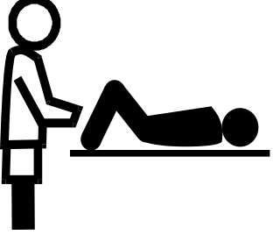 |  | 
Cervical smear examination  5753 | Condom  5754 | Confidential information  5755
 |  | 
Contraception  5756 | Counselling  5757 | Doctor  5758
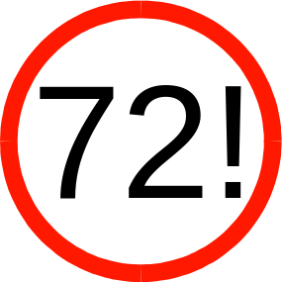 |  | 
Emergency contraception #1  5759  Bonnington Symbol System  www.edinburgh.gov.uk | Emergency contraception #2  5760 | Extra help or support  5761

 |  | 
Family  5762 | Family-adult female  5763 | Family-adult male  5764
 |  | 
Family-juvenile female  5765 | Family-juvenile male  5766 | Feelings  5767
 |  | 
Female  5768 | Female/ female  5769 | Friends  5770
 | 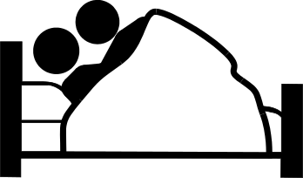 | 
Gay or lesbian  5771  Bonnington Symbol System  www.edinburgh.gov.uk | Having sex  5772 | Heterosexual relationship  5773
 |  | 
Homosexual relationship  5774 | Information  BS 8501 6001 | Lesbian relationship  5775
 |  | 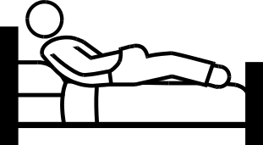
Male/male  5776 | Male  5777 | Masturbation  5778
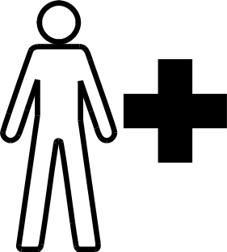 | 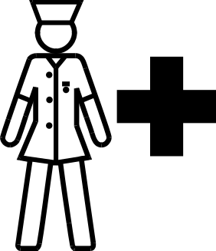 | 
Nurse-generic  5779 | Nurse-practice nurse  5780 | Periods  5781
 |  | 
Pregnancy  5782  Bonnington Symbol System  www.edinburgh.gov.uk | Relationships  5783 | Sexual or physical abuse  5784
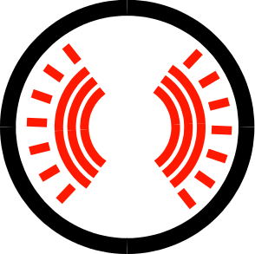 | 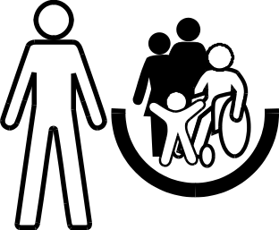 | 
Sexually transmitted infections  5785 | Social worker  5786 | Support worker  5787
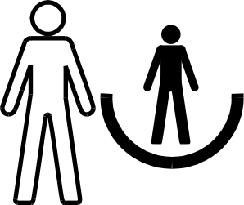 | 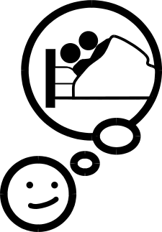 | 
Support  5788 | Thinking of having sex  5789 | Wheelchair user  BS 8501 4106
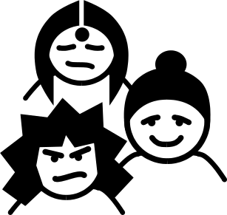 | 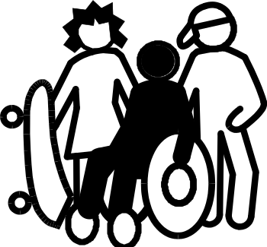 | 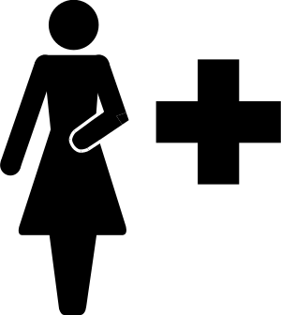
Young people #1  5790 | Young people #2  5791 | Your health-female  5792
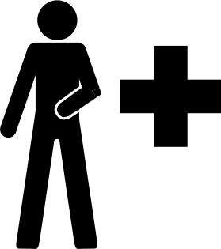 | 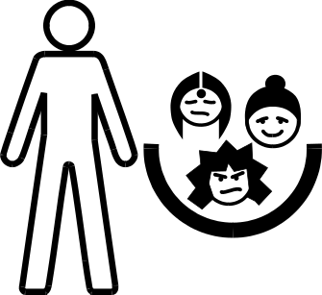 | 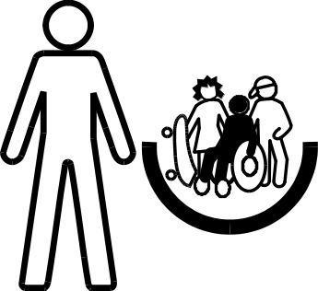
Your health-male  5793 | Youth worker #1  5794 | Youth worker #2  5795
Bonnington Symbol System
www.edinburgh.gov.uk

